Preparing DevOps Environment



>> Installing these resource is key:

* AWS account
* Github account
* Dockerhub account
* Java21
* Git
* Maven
* IntelliJ Idea
* VScode
* Terraform

Steps to create dev machine:

>> Download, install, configure path for jdk

>> Download and install for Git

>> Download and configure path for maven, terraform

>> Download and install VScode, intelliJ IDEA

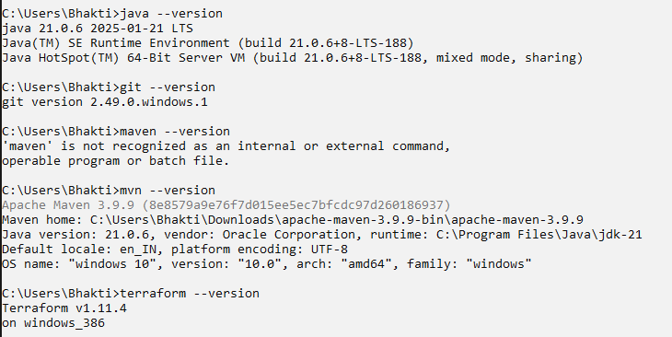

>> AWS account to work with cloud

>> Github account is an account to work with world code like Jenkins, maven, terraform, kubernetes, docker, helm; github is a repo-place where all the source code repositories are stored

>> Dockerhub account is an account to work with docker images, basically a repository storing the images